An Ethical Framework for Assessing How to Respond to Patient or Family Bias
Adapted from an ED model by Paul-Emile, Smith, Lo, and Fernandez (2016)

Patients’ medical condition: metabolic and chemistry imbalance, medication influenced, psychosis, delirium, mania, trauma Impact on family: Sudden onset vs decline, health literacy, shock, family dynamics, culture or language barriers
Patients’ decision-making capacity: dementia, sepsis/shock, LOC, cognitive impairment Family: designated surrogate? knowledge of patient, impairment
Reasons for the behavior/assessing accountability: Fear, anger, pain, control. Is the intent of patient/family to inflict harm? Is awareness and intent of remarks and behaviors low? Intention may be unclear. Does not erase moral responsibility for the effects of the remarks or behaviors and should be addressed
Effect on the caregiver: Effect on the victim is thought to be worse when accountability is judged to be high but even in someone not accountable, the remark or behavior can still be profoundly wounding
Options for response to the bias/discrimination: in clinic and on the service: does the patient need to be stabilized? Should they be transferred to another physician or service? Should they be sent to another facility? What is institutional policy? Does the program allow residents to withdraw from care? Can patient be terminated from clinic? Can family be asked to remain away?
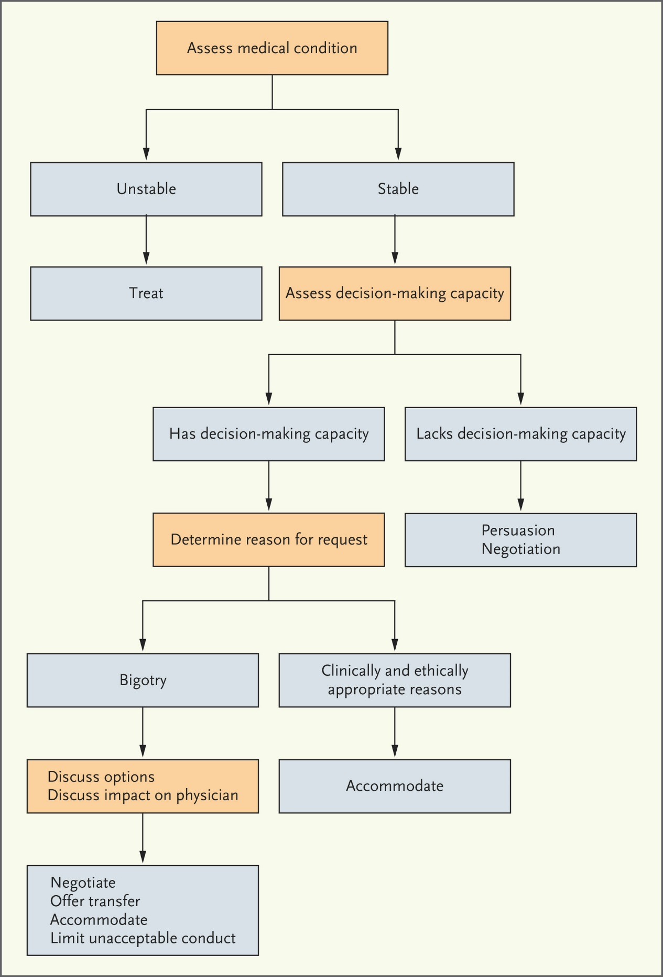
n engl j med 374;8 nejm.org February 25, 2016 Paul-Emile, Smith, Lo, and Fernandez (2016)

