FEEDBACK CASE 1: RESIDENT
While working with a medical student throughout a regular clinic day, you notice that their presentations could be improved. You have a hard time understanding what diagnosis the student is trying to make, and their presentations are unorganized, leading to more confusion between the two of you. They seem to have good rapport with patients and did a good job with a directly witnessed abdominal exam. You set aside a short amount of time at the end of your clinic half day to do some quick feedback with the student.

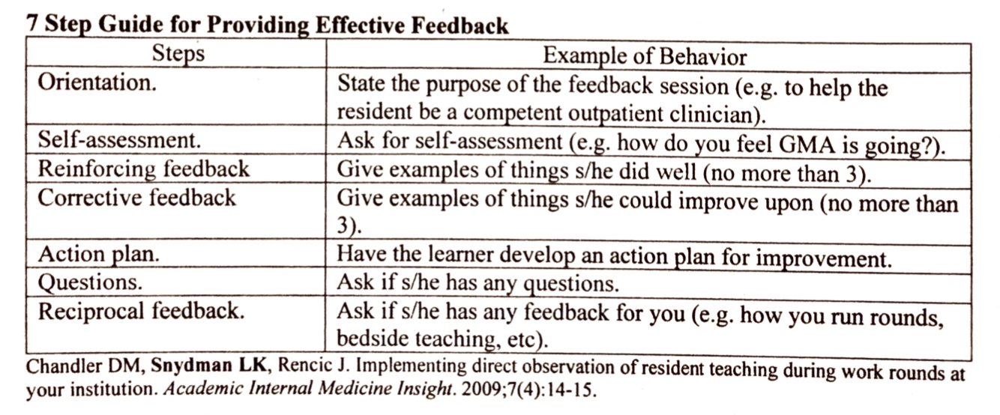

RESIDENT Sample Responses for Feedback
Feedback Steps | Sample response
Orient the student to feedback | This is a feedback session. My goal is to help you succeed as you move on in this clerkship and with the rest of medical school.
Ask for a self-assessment | How do you think you did today? How did your presentations go?
Reinforcing feedback (no more than 3) | I noticed that patients really opened up to you when you spoke to them. You also performed a thorough and detailed abdominal examination on the patient we saw together.
Corrective feedback (no more than 3) | One thing I noticed was that your presentations were a little bit unorganized. There were times that I wasn’t sure what your diagnosis was, and how you reached that point.
Action plan (learner developed) | What are some things that you could do to improve your presentations?
Questions | Do you have any questions or clarifications for me?
Reciprocal Feedback | Do you have any feedback on my feedback, or about anything else you saw today in clinic with me?

The purpose of this case is to focus on helping to develop a learner-driven action plan. The approach to this is the same as utilizing motivational interviewing and SMART goals with patients. When the learner generates the goals, they are more likely to go through with them. Keep the goals specific, measurable, attainable, realistic, and timely (SMART).
If you can, develop a plan for follow-up. Check in with the learner after a certain timeframe and see how they are going with their goal.
FEEDBACK CASE 1: Medical Student
You had a half day with the resident. You are at the beginning of your third year and developing presentations is still something you are struggling to work on. You feel that you don’t have a good order for how to present your presentation, and also are not sure how to frame your differentials at the end of your presentation. You are not sure how best to approach fixing this.
Feedback Steps | Sample response
Orient the student to feedback | n/a
Ask for a self-assessment | I think I did okay. I think my presentations could use some work though. I feel like I am getting the information, but I’m not sure how to organize it when I talk to somebody else.
Reinforcing feedback (no more than 3) | n/a
Corrective feedback (no more than 3) | n/a
Action plan (learner developed) | Initial: “I’ll definitely focus on it in the future”  If prompted more: “I will try to organize my presentations better and try to keep the physical exam separate from the subjective. I will also try to give 3 differential diagnoses at the end of my presentation with the most likely first.”
Questions | Up to you (the roleplay student)
Reciprocal Feedback | Up to you (the roleplay student)

