Task: Please match the correct price to each escape room supply item! Once you think you’ve matched them correctly, ask your group leader to verify.

Shelesky et al, Escaping the Average Teaching Technique, STFM Annual Conference, 2019

Invisible Ink Pens and UV Lights (4/Pack)

LED UV Flashlight

Shelesky et al, Escaping the Average Teaching Technique, STFM Annual Conference, 2019

Assorted Color Index Cards (100/Pack)
Manilla Envelopes (100/Pack)

Master Lock Combination Locks (Each)

Shelesky et al, Escaping the Average Teaching Technique, STFM Annual Conference, 2019
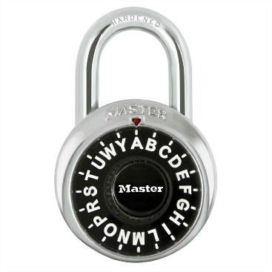

Speed Dial Set-Your-Own Combination Padlock
$7.98
$4.98 $12.34 $5.88 $2.91 $14.98

Shelesky et al, Escaping the Average Teaching Technique, STFM Annual Conference, 2019

