FEEDBACK CASE 2: RESIDENT
You have a well-woman exam scheduled during a regular clinic day. The medical student successfully identifies the required screening tests needed for the patient and takes a thorough history. Your medical student asks to try a Pap smear as they have only done one before. During the speculum exam, they are unable to locate the cervix, and you end up stepping in to finish the exam. It is the end of the clinic half day and you want to sit down briefly to provide some feedback on how the half day went.

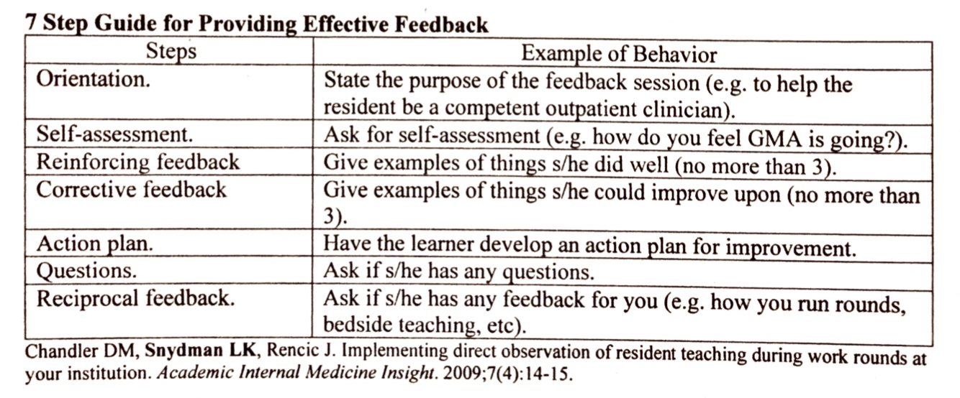

Sample Responses for Feedback
Feedback Steps | Sample response
Orient the student to feedback | This is a feedback session. My goal is to help you succeed as you move on in this clerkship and with the rest of medical school.
Ask for a self-assessment | How do you think you did today? How did the pap smear go?
Reinforcing feedback (no more than 3) | You were definitely on top of your preventative medicine screening recommendations. You picked up on all of the tests that she needed.
Corrective feedback (no more than 3) | It definitely takes time and practice to get better at pap smears. One thing to consider to more easily find the cervix would be to start with more downward pressure, and then start to look upwards for the cervix.
Action plan (learner developed) | Thinking about how things went today, what is something you can do the next time you have to do a pap smear?
Questions | Do you have any questions or clarifications for me?
Reciprocal Feedback | Do you have any feedback on my feedback, or about anything else you saw today in clinic with me?

This case focuses on obtaining a self-assessment from the learner. Self-assessment is important in order to assess the level of insight that the learner has – most of the time, people will realize when things are going well or not. Self-assessment encourages the long-term habit of self reflection and helps feedback be more bidirectional.
In addition, getting a self-assessment can help avoid duplicating effort; if the learner already identifies what you were going to talk about in the corrective feedback, you can use their self-assessment to lead into your corrective feedback.
FEEDBACK CASE 2: MEDICAL STUDENT

You saw a well-woman exam with the resident you were working with. You did a lot of pre-reading and reviewed the patient’s chart, and took the history and made a list of labs the patient was due for. You wanted to try to do the pap smear as you have only done one before. During the speculum exam, you were unable to locate the cervix and the resident needed to step in. You feel embarrassed and can’t think of anything good that you did off the top of your head.

Feedback Steps | Sample response
Orient the student to feedback | n/a
Ask for a self-assessment | Initial: I feel like I was terrible today.  If prompted: Well, I think I tried to make the patient feel comfortable, and I think we connected well. I don’t know if I was looking in the right place for the cervix, and I don’t know why I couldn’t find it.
Reinforcing feedback (no more than 3) | n/a
Corrective feedback (no more than 3) | n/a
Action plan (learner developed) | Up to you (the roleplay student)
Questions | Up to you (the roleplay student)
Reciprocal Feedback | Up to you (the roleplay student)

