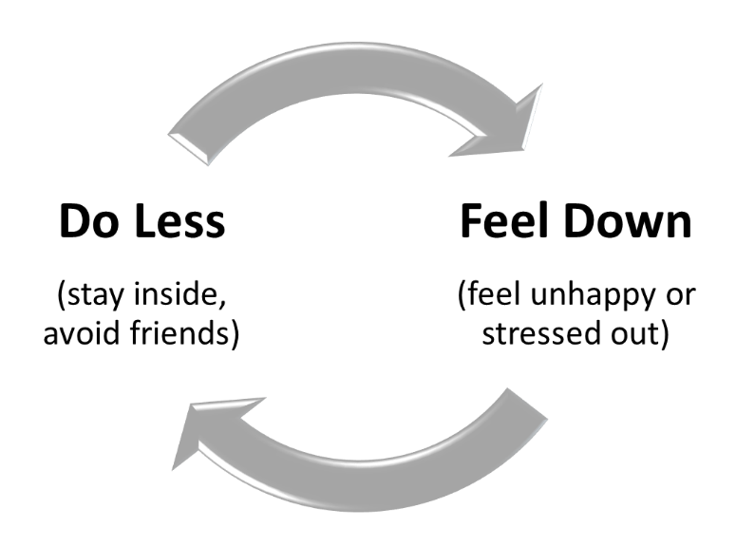
When you feel down, doing something active and positive can help you feel better. Don’t give in to feeling down, stressed out and depressed. Take action in ways to meet your GOALS.

Positive Activities: What are activities I can do that help me feel better? Chose something fun, helping others or helping myself:
_________________________________________________________
_________________________________________________________
Set a Goal: What is one goal that I can to reach?
_________________________________________________________

List the steps to take to reach my goal and when I will do it:
Steps to my GOAL: | When I will do it:
1.
2.
3.
EPIC SmartPhrase: BHPEDSBEHAVIORALACTIVATION
Created from multiple sources by RBK: Richard.Brandt-Kreutz@providence.org

