Solve the Rebus below! Once you have decoded it, please bring it to your facilitator for your piece of the code to unlock the Final envelope.
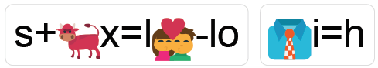
Example: Solve the puzzle =
S + (ox, where x = l) (love – lo) = SOLVE (tie, where i=h) = THE P+ (up, where p=z) + z + (left – ft) = PUZZLE

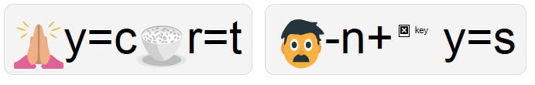

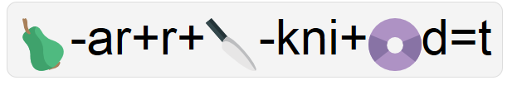

Shelesky et al, Escaping the Average Teaching Technique, STFM Annual Conference, 2019

