Decoder
where A =A and O = O and S =S and W = W

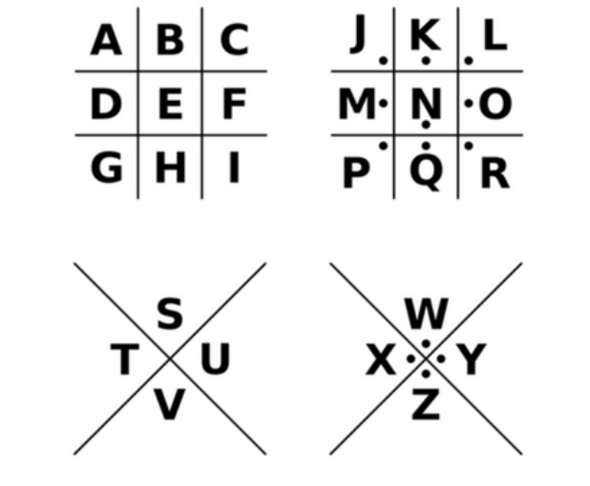
Shelesky et al, Escaping the Average Teaching Technique,
STFM Annual Conference, 2019

Decoder
where A =A and O = O and S =S and W = W

Shelesky et al, Escaping the Average Teaching Technique,
STFM Annual Conference, 2019

