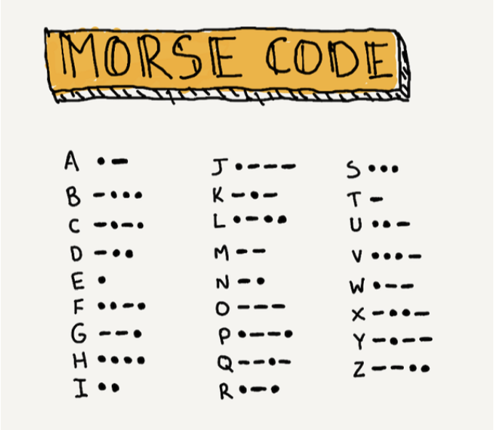
Shelesky et al, Escaping the Average Teaching Technique, STFM Annual Conference, 2019

Shelesky et al, Escaping the Average Teaching Technique, STFM Annual Conference, 2019

