Evidence-Based Medicine Guide
The purpose of this guide is for you to practice evidence-based medicine (EBM), illustrate for your peers the process of EBM, and help you in clinical years when you have to make a quick presentation to impress your attending.
Your presentation should be no more than 5 minutes, followed by 5 minutes of group discussion. It may be helpful to provide a handout with your question and abstract of the study you explored, but is not required. This is NOT a PowerPoint presentation.
Your presentation will follow the guideline of the “Evidence Cycle¹:” Assess, Ask, Acquire, Appraise, and Apply.
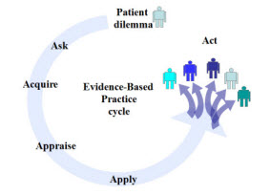

Assess:
- Establish the situation – provide a background of the patient, their pertinent past medical history, and physical exam findings.
- Present any background questions you might have and their answers.
- This is your opportunity to provide us with a broad overview so that we understand why an intervention or investigation is needed.

Ask:
- Your specific foreground question will guide your entire investigation. Formulate your question in the PICO format and identify for us each aspect of PICO in your presentation.
- Example: For low-income patients with Type 2 Diabetes, would providing tokens to Farmer’s Markets through their Food Stamp program when compared to standard Food Stamp policy reduce their A1C levels?
  - P: low-income patients with Type 2 Diabetes
  - I: tokens to Farmer’s Markets
  - C: standard Food Stamp policy
  - O: reduce A1C levels

The following tool may help you organize your thoughts:
Question Components | Your Question
P – Patient or Population

Describe the most important characteristics of the patient.
(e.g., age, disease/condition, gender)

I – Intervention; Prognostic Factor; Exposure

Describe the main intervention.
(e.g., drug or other treatment, diagnostic/screening test)

C – Comparison (if appropriate)

Describe the main alternative being considered.
(e.g., placebo, standard therapy, no treatment, the gold standard)

O – Outcome

Describe what you’re trying to accomplish, measure, improve, affect.
(e.g., reduced mortality or morbidity, improved memory, accurate and timely diagnosis)

The well-built clinical question:

Acquire:
- In this part of the presentation, you will discuss your search strategy: the resources you accessed, the way you searched for your sources, and reasons for selecting the particular sources you found.
- Here’s a tool to help you direct your search based on your question: http://www.dartmouth.edu/~biomed/resources.htmld/guides/FindingGoodAnswers.pdf
- Spoiler alert, PubMed is your friend. Some tips² on effectively searching it:
  - Draw core concepts from your PICO question in your search terms
  - Choose about 3 core concepts to start with
  - Linking synonyms with “OR” can broaden your results
  - Avoid abbreviations
  - Filter bar can help you find the best evidence (RCT’s vs Cohort studies)
  - MeSH terms may not provide the most current evidence because it takes time for articles to be indexed
Here’s how you should prioritize the studies you select to include in your investigation based on the question you’ve posed:
Type of Question | Ideal Type of Study
□ Therapy | RCT
□ Prevention | RCT > Cohort Study > Case Control
□ Diagnosis | Prospective, blind controlled trial comparison to gold standard
□ Prognosis | Cohort Study > Case Control > Case Series/Case Report
□ Etiology/Harm | RCT > Cohort Study > Case Control
□ Cost analysis | economic analysis
Note: Meta-analyses and systematic reviews, when available, often provide the best answers to clinical questions.

Appraise:
- For the one study you select from your search to present, you must generally assess it upon 3 criteria: validity, significance, and generalizability.
- Below is a table that can help guide your assessment of studies concerning “Therapy.” Do note that your assessment may change for systematic reviews, economic analyses, or studies about “Harm” or “Screening.” You can find all the various templates for your study here: http://guides.mclibrary.duke.edu/c.php?g=158178&p=1035917

How serious is the risk of bias?
Did intervention and control groups start with the same prognosis?
Were patients randomized?
Was randomization concealed?
Were patients in the study groups similar at baseline with respect to prognostic factors?
Was prognostic balance maintained as the study progressed?
To what extent was the study blinded?
Were groups prognostically balanced at the study’s conclusion?
Was follow-up complete?
Were patients analyzed in the groups to which they were randomized?
Was the trial stopped early?
What are the results?
How large was the treatment effect?
How precise was the treatment effect?
How can I apply the results to my patient care?
Were the study patients similar to my patient?
Were all patient-important outcomes considered?
Are the likely benefits worth the potential harms and costs?

Apply:
- Conclude your presentation with a brief discussion on how you envision your investigation being used in practice.
- According to the Icahn School of Medicine, application requires the most skill as you must “synthesize the best scientific knowledge with your clinical expertise and the patient's unique values and circumstances to reach a clinical decision.”³
- In effect, what is your plan now that you have the necessary information?
Works Cited
- http://www.dartmouth.edu/~biomed/services.htmld/EBP_docs/evidencecycle.pdf
- http://libguides.mssm.edu/ebm/acquire
- http://libguides.mssm.edu/ebm/EBM-Apply

Study Designs
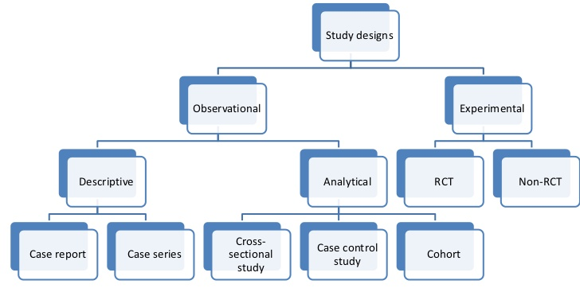
Study Type | Description | Moment in Time | Examples | stats
Cross-Sectional | Analysis of data at a specific point in time | Snapshot: one moment in time | How many medical students at OHSU experience depression? | Prevalence
Case control | Compares patients who have a disease to those who do not and looks back at exposures | Retrospective investigation | Do migraine patients have lower levels of Vitamin D compared to non-migraine patients? | Odds Ratio
Cohort | One or more samples with specific risk factors or characteristics are followed over time with respect to a disease or outcome | Prospective | Is sleep quality and duration a risk factor for coronary heart disease? | Incidence  Relative Risk
randomized control trial | Randomly assigns individuals into an experimental group or a control group | Prospective | Does addition of a yoga regimen improve chronic low back pain? | Relative Risk  Number Needed to Treat/harm
case report/case series | Describes and interprets an individual case or cases. Unusual presentations or a disease with a very low prevalence. | Retrospective | Consideration of nutritional deficiencies in patients with food sensitivities: A Case Report | n/a

Statistical Testing
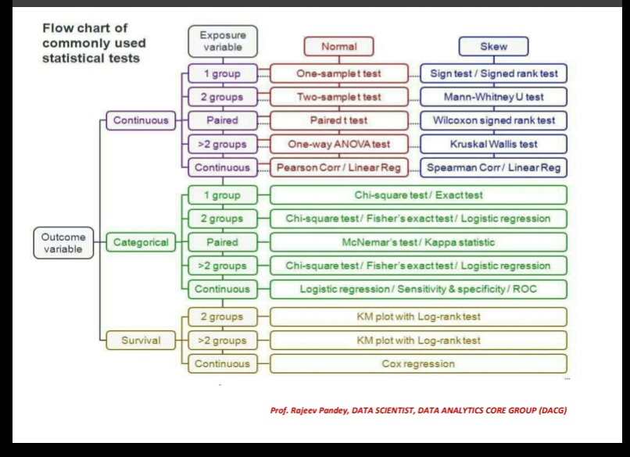
Variables:
- How you define your variables are important. Sometimes, you can make variables continuous or categorical depending on your needs.
  - For example: Weight
    - Weight can be continuous when you record and compare by pounds. However, this may not serve your purpose so instead you divide your participants into group by BMI. This makes it categorical.
Logistic Regression vs Linear Regression:
- Linear regression is used with continuous variables, logistic regression with categorical variables.
- Example for Linear Regression: Waist circumference (continuous variable) and triglyceride measurements (continuous variable) in relation to cardiovascular risk.¹
  - Independent variable (x)= waist circumference
  - Dependent variable (y)= triglycerides
  - Questions you can answer with linear regression.
    - What proportion of the variance in blood triglycerides is explained by waist circumference?
    - How large is the change in the expected value for blood triglycerides per unit of change in waist circumference (slope)? Is this statistically significant?
  - Analysis will give you an equation that represents a line y=mx+b. You can add more variables to the logistic regression.
- Example for Logistic Regression: Case-control study performed to determine association between lung cancer and cigarette smoking. The output (y) is in log odds. Therefore, logistic regression can always be used in case control studies; when we calculate an odds ratio.²
  - Confounding variables= age, sex
  - Exposure= smoking
  - Y variable=number of people with lung cancer

References
- Suarez, E; Perez, CM; Rivera Roberto; Martinez, M. Applications of Regression Models in Epidemiology. 2017. (Can be found on OHSU library website).
- https://towardsdatascience.com/understanding-logistic-regression-using-a-simple-example-163de52ea900

