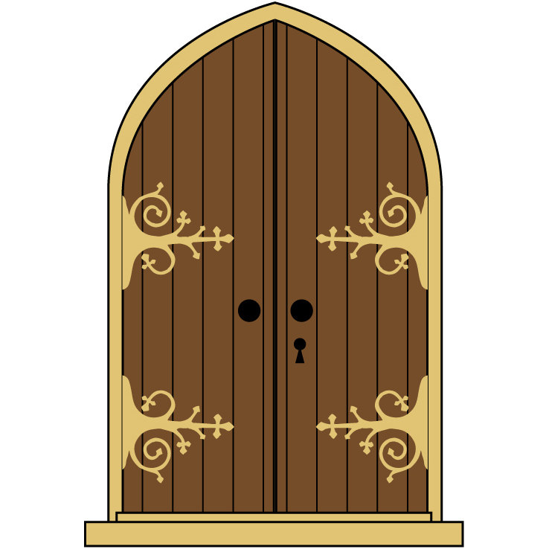

Please use the other door.
This one will remain closed for the duration of the Escape Room session.

