Here Comes Gen Z!
Facilitating success with the newest generation of medical learners
FMEC Annual Meeting • November 11, 2018
Jennifer L. Middleton, MD, MPH, FAAFP

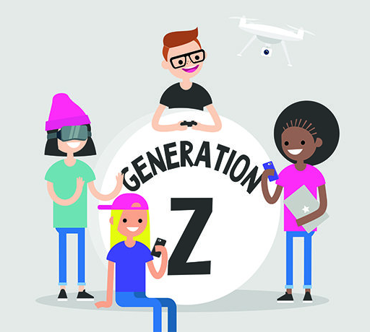
Objectives:
- Discuss the social forces that have shaped Gen Z.
- Define “phygital,” “hyper-custom,” and “FOMO.”
- Describe the typical work orientation of Gen Z.
- Brainstorm strategies for working successfully with Gen Z learners.

1. Discuss the social forces that have shaped Gen Z
- Born 1995-2012
  - 24.3% of US population (largest current generation!)
  - oldest members of Gen Z are in medical school now
  - Millennial/Gen Z “bridgers” in residency now

- Pragmatic, the world is not a safe place (9/11, school violence, mass shootings)
  - Expect to work harder than previous generations (do not remember time before Great Recession)
  - Wear seat belts more, drink less, less teen pregnancy than previous generations
  - Need their work to matter/help others/the world

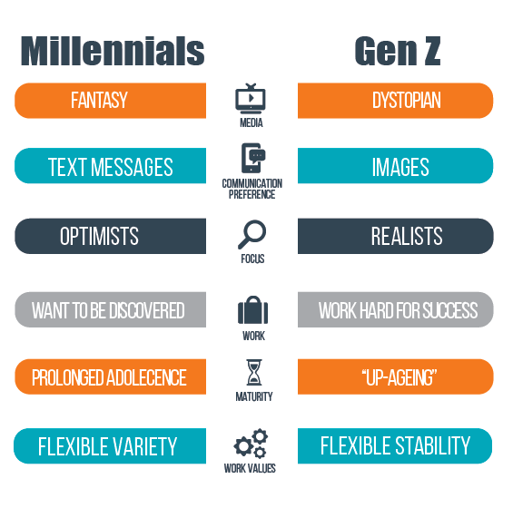
- Most culturally diverse generation in US history
  - 48% are non-Caucasian
  - 59% have at least 1 LGBTQ+ friend
  - Place high value on inclusivity
  - Less patriotic, more globally inclined

- Visual generation: communicate in pictures/videos, not words
  - They don’t text each other, they Snapchat
  - Watch an average of 68 videos a day (Snapchat, YouTube, Instagram)

Activity 1:
Break into groups of 3-4.
How might these traits & influences affect Gen Z medical learners?

______________________________________________________________________

______________________________________________________________________

______________________________________________________________________

______________________________________________________________________

______________________________________________________________________

______________________________________________________________________

______________________________________________________________________
2. Define “phygital,” “hyper-custom,” and “FOMO.”

“phygital” = no distinction between physical world and digital world

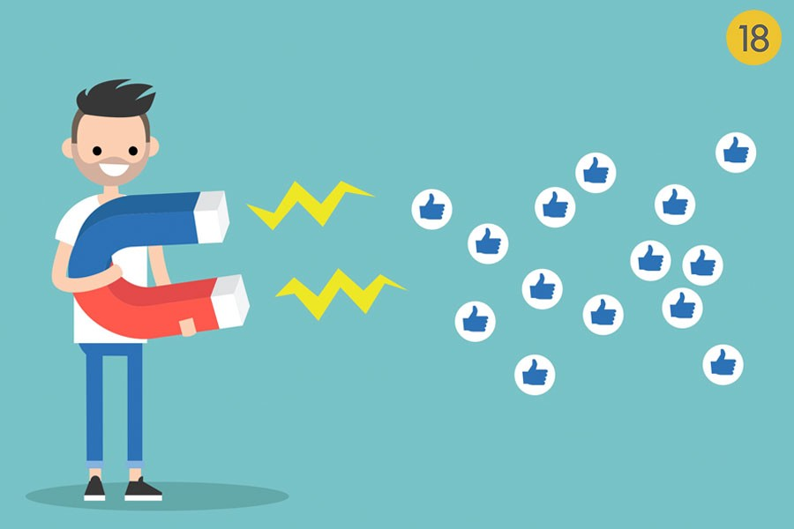

“hyper-custom” = expect to be able to personalize/customize all experiences
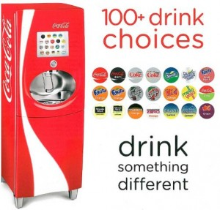

“FOMO” = Fear of Missing Out
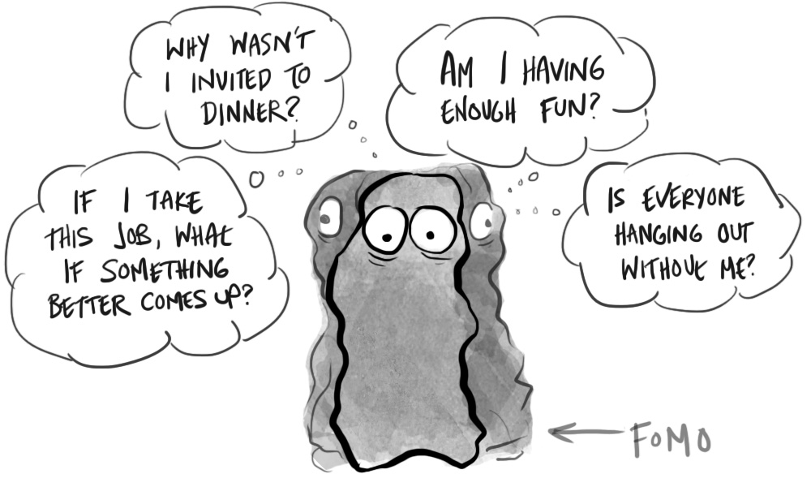

Activity 2:
Pair up with another attendee who identifies as part of your generation.

- How do you communicate with friends/family?

____________________________________________________________

____________________________________________________________

- Get your news?

____________________________________________________________

____________________________________________________________

- Listen to music?

____________________________________________________________

____________________________________________________________

- Watch TV/movies/videos?

____________________________________________________________

____________________________________________________________

We’ll share and compare these answers as a large group.

3. Describe the typical work orientation of Gen Z.
- Pragmatic
- Competitive
- Connected
- Socially responsible
- Customizers
- Plugged in
- Self-reliant
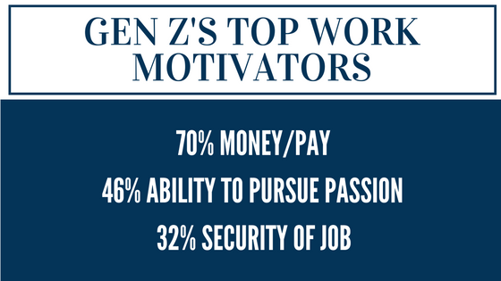

Gen Z longs for the financial security their parents (Generation X) didn’t have. They expect to work hard, but they are unwilling to set aside their desire to help others. If their day job won’t allow for them to satisfy their philanthropic wishes, many will turn to a side hustle….

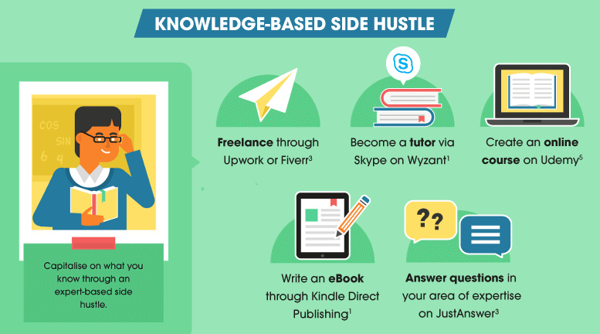

Side hustle = A secondary job/career, allows for use of skills/interests that are not met by main (“bread-winning”) job. Many Gen Zers will already have a side hustle when they come to medical school and residency.

Activity 3:
Which of these Gen Z work attributes resonates most with you?
Jot them down (or circle above) and then discuss with 1-2 others near you.

______________________________________________________________________

______________________________________________________________________

4. Brainstorm strategies for working successfully with Gen Z learners.

What challenges do you anticipate with Gen Z?

______________________________________________________________________

______________________________________________________________________

What opportunities do you foresee?

______________________________________________________________________

______________________________________________________________________

What strategies might be useful?

______________________________________________________________________

______________________________________________________________________

What one action can you commit to re: preparing for Gen Z?

______________________________________________________________________

______________________________________________________________________

Primary references
- Stillman, David, and Jonah Stillman. Gen Z @ Work: How the next Generation Is Transforming the Workplace. Harper Business, an Imprint of Harper Collins Publishers, 2017.
- Eckleberry-Hunt J, Lick D, Hunt R. Is Medical Education Ready for Generation Z? J Grad Med Educ. 2018 Aug;10(4):378-381.

Jennifer.Middleton@OhioHealth.com
@SingingPenDrJen

