There are many free electronic tools to use online, including resources to create fake Facebook conversations. Find the hidden message within this Facebook conversation. See the facilitator to confirm you are correct to receive your piece of the final puzzle for this station.
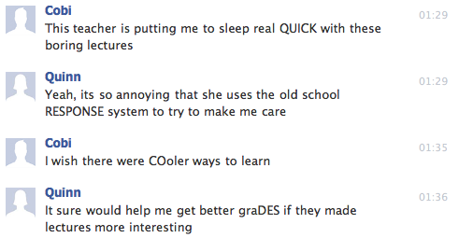

Shelesky et al, Escaping the Average Teaching Technique, STFM Annual Conference, 2019

There are many free electronic tools to use online, including resources to create fake Facebook conversations. Find the hidden message within this Facebook conversation. See the facilitator to confirm you are correct to receive your piece of the final puzzle for this station.

Shelesky et al, Escaping the Average Teaching Technique, STFM Annual Conference, 2019

