There are many free electronic tools to use online, including resources to create fake receipts.
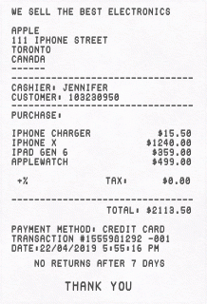
To open the lock, use your receipt. The object inside the envelope will be useful once everyone has finished their puzzles.

Shelesky et al, Escaping the Average Teaching Technique, STFM Annual Conference, 2019

There are many free electronic tools to use online, including resources to create fake receipts.
To open the lock, use your receipt. The object inside the envelope will be useful once everyone has finished their puzzles.

Shelesky et al, Escaping the Average Teaching Technique, STFM Annual Conference, 2019

